UNIVERSITY OF WAH (UOW)

DEPARTMENT OF COMPUTER SCIENCE



COURSE TITLE: ARTIFICIAL INTELLIGENCE

COURSE CODE: CS – 202 L

SUBMITTED TO: SIR HASSAN SHAFAQAT

SUBMITTED BY: SAADI SAFDAR

REG #: UW-24-CS-BS-088

BSCS 3RD B

LAB TASK # 6

1. Line Plot(Matplotlib)
import matplotlib.pyplot as plt
x = ['Mon', 'Tue', 'Wed', 'Thu', 'Fri', 'Sat', 'Sun']
y = [5, 6, 8, 7, 9, 10, 8]
plt.plot(x, y, color='blue', linestyle='-', linewidth=2, marker='s', markersize=8)
plt.title('Daily Water Intake Over a Week')
plt.xlabel('Days')
plt.ylabel('Glasses of Water')
plt.grid(True)
plt.show()

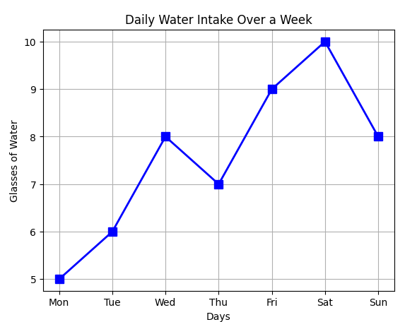

2. Bar Chart
import matplotlib.pyplot as plt
x = ['Mon', 'Tue', 'Wed', 'Thu', 'Fri', 'Sat', 'Sun']
y = [45, 60, 50, 70, 85, 95, 90]
plt.bar(x, y, color='orange', edgecolor='black', linewidth=1.5, width=0.5)
plt.title("Coffees Sold per Day")
plt.xlabel("Days")
plt.ylabel("Number of Coffees")
plt.grid(False)
plt.show()

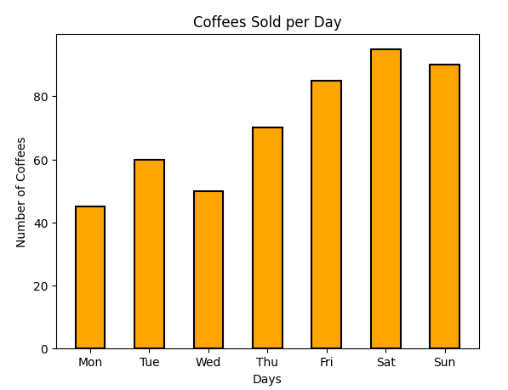

3. Histogram
import matplotlib.pyplot as plt
sleep_hours = [5, 6, 7, 8, 5, 6, 7, 7, 8, 9, 5, 6, 8, 9, 7]
plt.hist(sleep_hours, bins=5, color='cyan', edgecolor='black', alpha=0.7, linewidth=1.5)
plt.title('Distribution of Sleep Hours Among Students')
plt.xlabel('Hours of Sleep')
plt.ylabel('Frequency')
plt.grid(True)
plt.show()

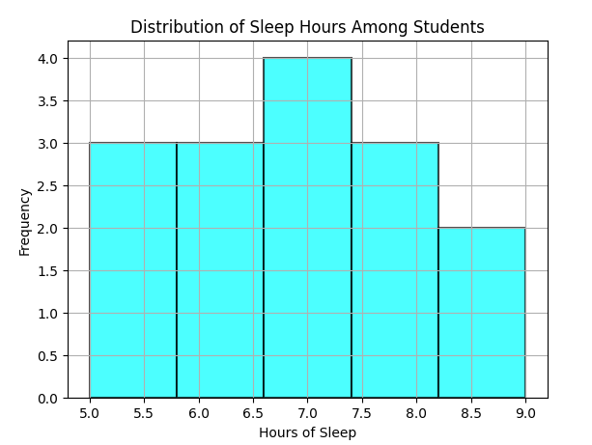

4. Scatter Plot
import matplotlib.pyplot as plt
x = [1, 2, 3, 4, 5, 6, 7, 8] # Hours spent on social media
y = [95, 90, 85, 80, 75, 70, 60, 55] # Exam scores
plt.scatter(x, y, color='magenta', s=100, alpha=0.6, marker='o')
plt.title("Social Media Hours vs. Exam Scores")
plt.xlabel("Hours on Social Media")
plt.ylabel("Exam Scores")
plt.grid(True)
plt.show()
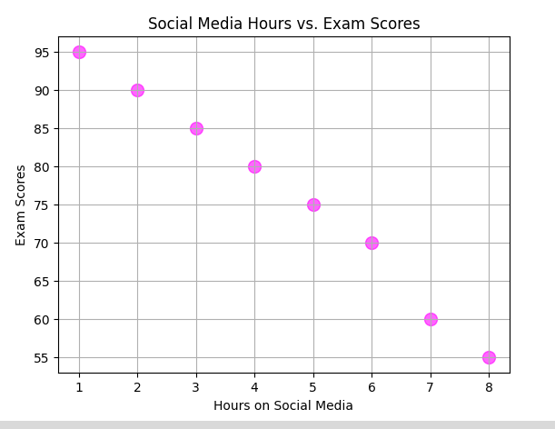

5. Pie Chart
import matplotlib.pyplot as plt
categories = ['Food', 'Rent', 'Transport', 'Shopping', 'Savings']
expenses = [25, 35, 15, 10, 15]
plt.pie(expenses, labels=categories, autopct='%1.1f%%', startangle=140, colors=['gold', 'lightcoral', 'lightskyblue', 'lightgreen', 'violet'])
plt.title('Monthly Expenses Distribution')
plt.show()
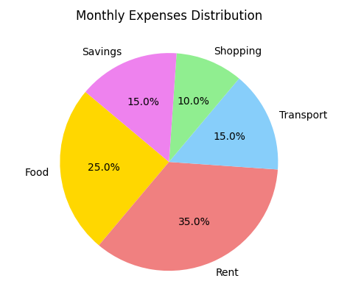

6. Area Plot
import matplotlib.pyplot as plt
import pandas as pd
data = {'Month': ['Jan', 'Feb', 'Mar', 'Apr', 'May', 'Jun'],
'Savings': [2000, 2500, 2700, 3000, 3500, 4000]}
df = pd.DataFrame(data)
df.plot(x='Month', y='Savings', kind='area', color='lightblue', alpha=0.5)
plt.title('Cumulative Savings Over Months')
plt.xlabel('Month')
plt.ylabel('Savings ($)')
plt.grid(False)
plt.show()

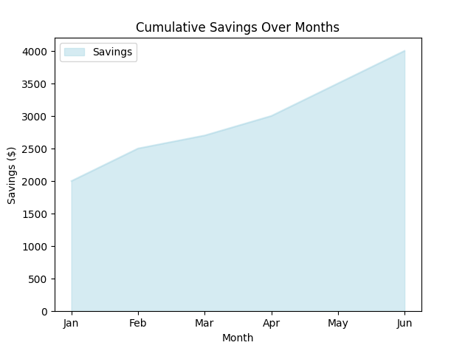

7. 3D Plot
import matplotlib.pyplot as plt
from mpl_toolkits.mplot3d import Axes3D
import pandas as pd
data = {
'Age': [18, 19, 20, 21, 22],
'Study_Hours': [2, 3, 4, 5, 6],
'Exam_Score': [60, 70, 75, 85, 90]
}
df = pd.DataFrame(data)
fig = plt.figure()
ax = fig.add_subplot(111, projection='3d')
ax.scatter(df['Age'], df['Study_Hours'], df['Exam_Score'], color='blue')
ax.set_xlabel('Age')
ax.set_ylabel('Study Hours')
ax.set_zlabel('Exam Score')
plt.title('3D Scatter Plot of Age, Study Hours, and Exam Score')
plt.show()

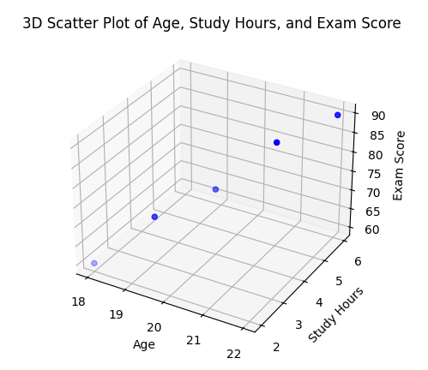

1. Bar Plot(seaborn)
import seaborn as sns
import pandas as pd
import matplotlib.pyplot as plt
data = {'Subject': ['Math', 'English', 'Science', 'History', 'Computer'],
'Average_Score': [82, 75, 89, 70, 95]}
df = pd.DataFrame(data)
sns.barplot(x='Subject', y='Average_Score', data=df, palette='pastel')
plt.title('Average Scores by Subject')
plt.xlabel('Subjects')
plt.ylabel('Scores')
plt.show()

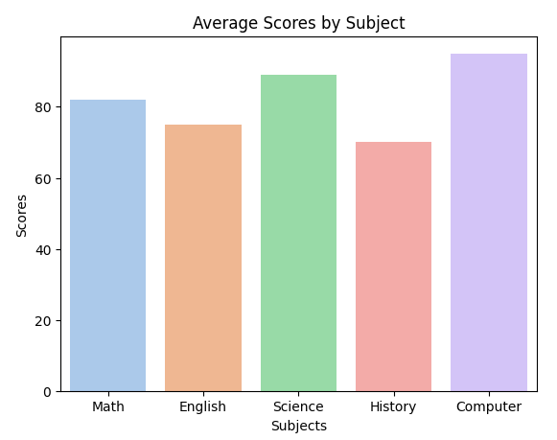

2. Line Plot
import seaborn as sns
import pandas as pd
import matplotlib.pyplot as plt
sales_data = {'Month': ['Jan', 'Feb', 'Mar', 'Apr', 'May', 'Jun'],
'Deliveries': [120, 140, 135, 160, 180, 200]}
df = pd.DataFrame(sales_data)
sns.lineplot(x='Month', y='Deliveries', data=df, marker='o', color='red')
plt.title('Monthly Deliveries Trend')
plt.xlabel('Month')
plt.ylabel('Number of Deliveries')
plt.grid(True)
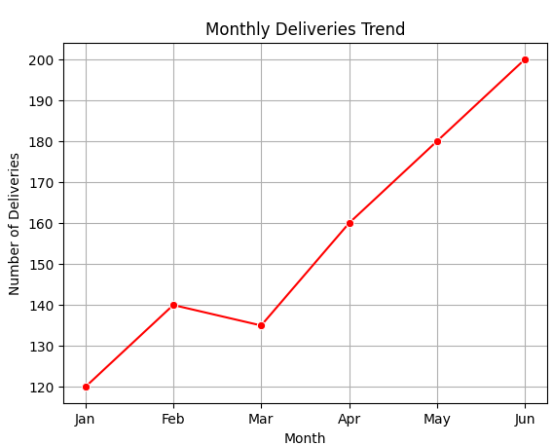
plt.show()

3. Histogram
import seaborn as sns
import pandas as pd
import matplotlib.pyplot as pltdata = {'Weight': [55, 60, 62, 65, 70, 72, 75, 80, 85, 90, 95, 100]}
df = pd.DataFrame(data)
sns.histplot(data=df, x='Weight', bins=5, color='teal')
plt.title('Distribution of Client Weights')
plt.xlabel('Weight (kg)')
plt.ylabel('Frequency')
plt.show()

